Day 19

DIY

Q1.Sticky sessions for your Application Load Balancer

Background:

The application Load Balancer routes each request independently to a registered target based on the chosen load-balancing algorithm. However, you can use the sticky session feature (also known as session affinity) to enable the load balancer to bind a user's session to a specific target. This ensures that all requests from the user during the session are sent

to the same target. This feature is useful for servers that maintain state information in order to provide a continuous experience to clients. To use sticky

sessions, the client must support cookies.

Application Load Balancers support both duration-based cookies and application-based cookies. Sticky sessions are enabled at the target group level.

You can use a combination of duration-based stickiness, application-based stickiness, and no stickiness across your target groups.

Solution –

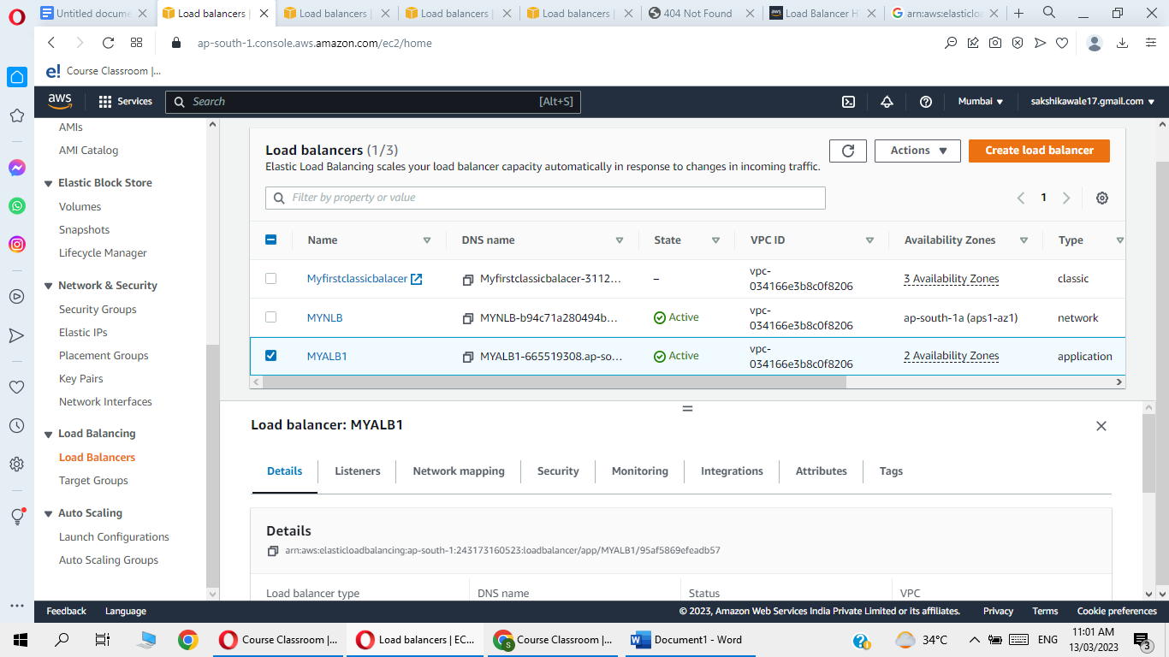

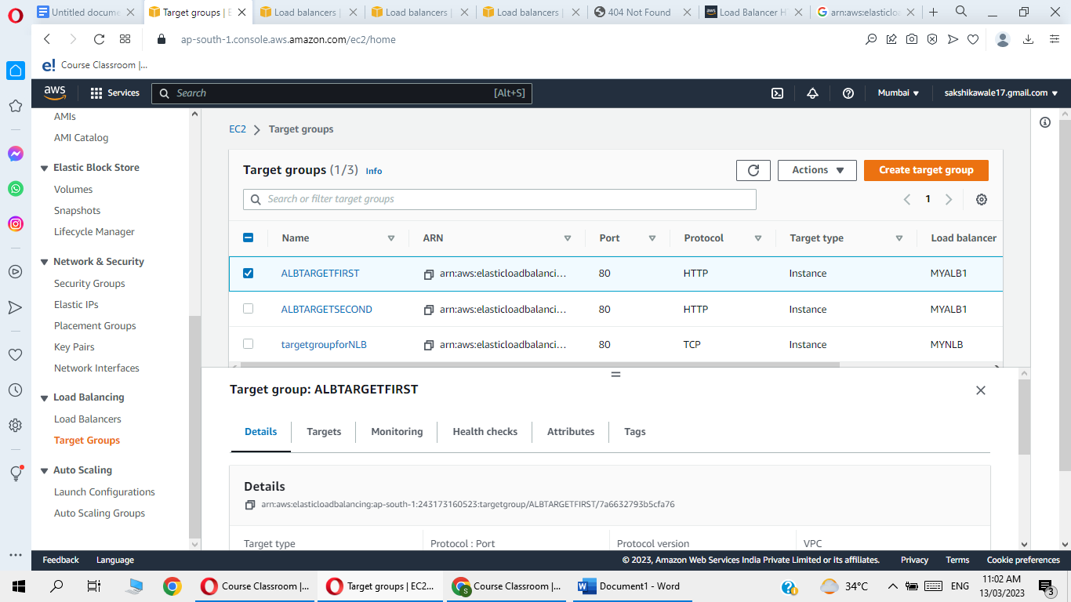

Go to attribute and enable sticky and set sitckness duration

